Alpha-Bisabolol

Certificate of Analysis

Batch No.: Check product package
Chemical Name: 3-Cyclohexene-1-methanol, α,4-dimethyl-α-(4-methyl-3-penten-1-yl)-, (αR,1R)-rel-
Expiry Date: October 2028

PHYSICAL AND CHEMICAL PROPERTIES

Molecular Formula: | C15H26O
Molecular Weight: | 222.37
Storage: | Pure form In solvent | -20°C 4°C  -80°C  -20°C | 3 years  2 years  6 months  1 month
Chemical Structure:

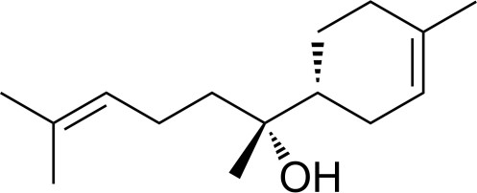

ANALYTICAL DATA
Appearance: Colorless to light yellow (Liquid)
1 H NMR Spectrum: Consistent with structure

Purity (NMR): ≥80.0%
Conclusion: The product has been tested and complies with the given specifications.

