Certificate of Analysis

Product Name: Coenzyme Q10 Batch No.: Check product package
IUPAC Name: Decamethyl-
tetracontadecaen-1-yl]-5,6-dimethoxy-3-methyl-2,5-cyclohexadiene-1,4-dione Expiry Date: August 2028

PHYSICAL AND CHEMICAL PROPERTIES
Batch Molecular Formula: C59H90O4

Batch Molecular Weight: 863.34
Physical Appearance: Orange crystalline solid
Solubility: oil heated to 120°F (49°C)
ethanol to 5 mM with gentle warming chloroform to 50 mM
Storage: Store at -20°C

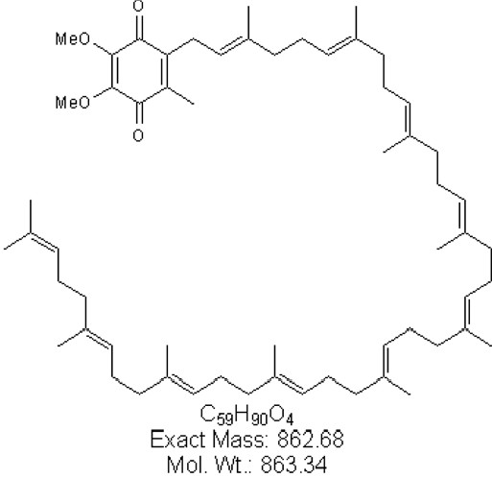
Batch Molecular Structure:

- ANALYTICAL DATA
HPLC: Shows >99.2% purity
Mass Spectrum: Consistent with structure

Product Information

Physical and Chemical Properties: Batch Molecular Formula: C₅₉H₉₀O₄ Batch Molecular Weight: 863.34
Physical Appearance: Orange crystalline solid

Minimum Purity: ≥99%
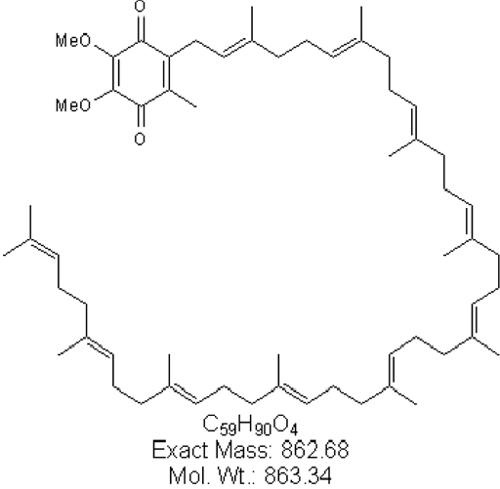
Batch Molecular Structure:
Storage: Store at -20°C
CAUTION - This product is light sensitive and we recommend that the solid material and any solutions obtained are protected from exposure to light.

Solubility & Usage Info:

Oil heated to 120°F (49°C)

Stability and Solubility Advice:
Some solutions can be difficult to obtain and can be encouraged by rapid stirring, sonication or gentle warming (in a 45-60°C water bath).
Information concerning product stability, particularly in solution, has rarely been reported and in most cases we can only offer a general guide. Our standard recommendations are:
SOLIDS: Provided storage is as stated on the product label and the vial is kept tightly sealed, the product can be stored for up to 6 months from date of receipt.
SOLUTIONS: We recommend that stock solutions, once prepared, are stored aliquoted in tightly sealed vials at -20°C or below and used within 1 month. Wherever possible solutions should be made up and used on the same day.

