Tetrahydrocurcumin

Certificate of Analysis

Batch No.: Check product package
Chemical Name: 3,5-Heptanedione, 1,7-bis(4-hydroxy-3-methoxyphenyl)-

PHYSICAL AND CHEMICAL PROPERTIES

Molecular Formula: | C21H24O6
Molecular Weight: | 372.41
Storage: | Powder In solvent | -20°C 4°C  -80°C  -20°C | 3 years  2 years  2 years  1 year
Chemical Structure:

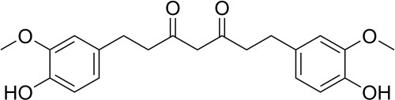

ANALYTICAL DATA
Appearance: White to off-white (Solid)
1 H NMR Spectrum: Consistent with structure
LCMS: Consistent with structure

Purity (LCMS): 98.96%

Exp Date: October 2028
Conclusion: The product has been tested and complies with the given specifications.

The above data were obtained using the test indicated and is subject to the deviation inherent in the test method. Results may vary under other test methods or conditions. This report is not to be signed. All data are as per our supplier.
Disclaimer: This information relates only to the specific material designated and may not be valid for such material used in combination with any other materials or in any other process. Such information is to be the best of the company’s knowledge and believed accurate and reliable as of the date indicated. However, no representation, warranty or guarantee of any kind, express or implied, is made as to its accuracy, reliability or completeness and we assume no responsibility for any loss, damage or expense, direct or consequential, arising out of use. It is the user’s responsibility to satisfy himself as to the suitableness & completeness of such information for his own particular use.

